Membership function(hydro and solar)

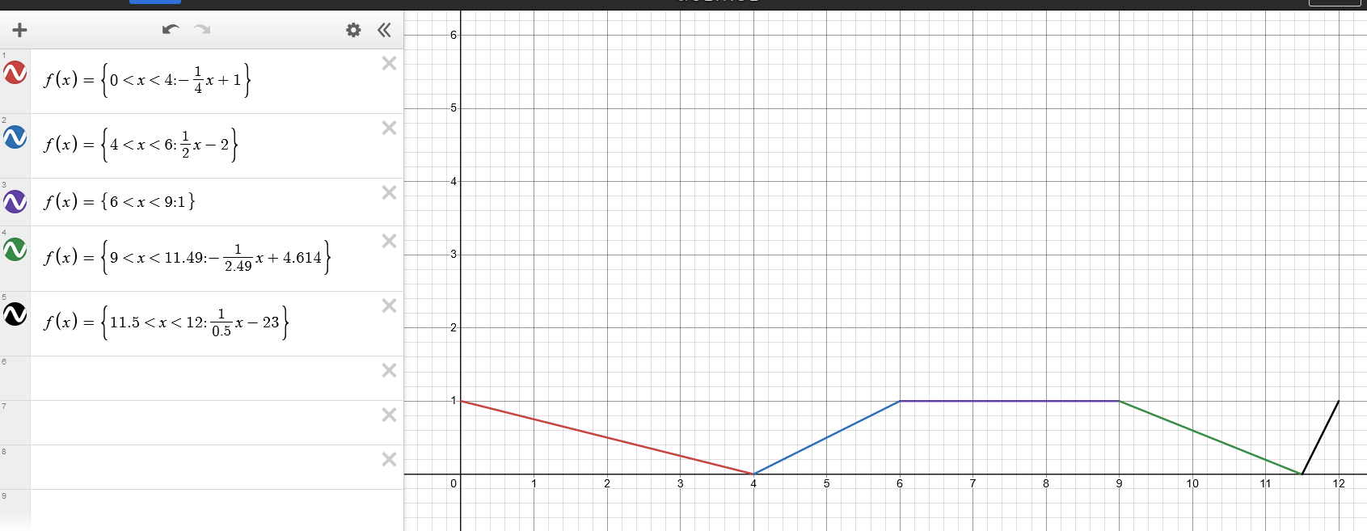

Red (x = 0V, y @ 1) – will not get power from source. Fully rely on grid or any other available source **that can provide 12V**

Red (x = 0V-4V, 0< y <0.99…) – source will provide to grid **to supply 12V**  
blue (x = 6V-9V, y @ 1) – will provide output to any other available source **to supply 12V**

Green(x = 9V-11.49V, 0< y <0.99…) – grid will supply to source **to produce 12V**

**Black(x=11.5V,** 0< y <1) – system relies on source unless another source can produce higher wattage (except grid)

Hi sir, try ko po iexplain via chat na lang kung kaya: Meron na po kasi akong membership function para po sa code based para po sa triple input single output power supply. Ang di ko lang po sure po kasi is kung tama ba po yung implementation ko ng rulesets and if ever paano ko maimplement yon sa arduino. Yung pic po yung membership function para sa mga sources. Ito naman po yung rulesets po: Red (x = 0V, y @ 1) – will not get power from source. Fully rely on grid or any other available source that can provide 12V Red (x = 0V-4V, 0< y <0.99…) – source will provide to grid to supply 12V blue (x = 6V-9V, y @ 1) – will provide output to any other available source to supply 12V Green(x = 9V-11.49V, 0< y <0.99…) – grid will supply to source to produce 12V Black(x=11.5V, 0< y <1) – system relies on source unless another source can produce higher wattage (except grid) May provided na fuzzy library is arduino na pwede ko magamit, pero di ko lang sure kung maiimplement niya ba yung mga different types ng membership function, since Fuzzyinput lang po nakikita kong parameter na pwedeng paggamitan po ng rulesets sa library. Another method na pwede ko pong gawin is implement yung function mismo sa arduino. Irekta ko yung function tas gamit ako if else para maimplement rulesets. Though di ko lang po sure kung considered fuzzy logic pa ba po yon. (edited)